PUMPKIN HEAD
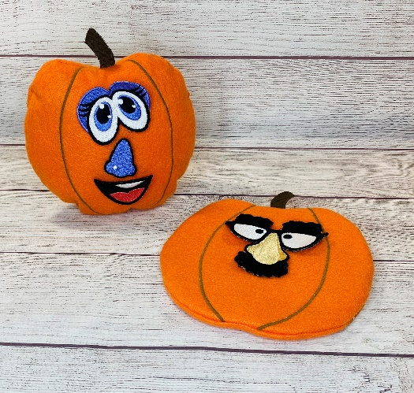

Materials:
- 8 x 8 and 4 x 4 Hoops
- Fabric for Pumpkin Head
- 9” x 9” orange felt= Front
- 9” x 4” orange felt= Top Back
- 9” x 7” orange felt= Bottom Back
- 9” x 9” cotton fabric= Back thread pocket
  - Fold in half and press well for a finished piece measuring 9” x 4 ½”
- Stabilizers:
  - Embellish® Soft Cutaway
  - Embellish® Iron-away Clear Topper
- RNK Embroidery Perfection Tape
- Poly-Fil®
- RNK Heat Craft Tool
- RNK Precision Turning Tool
- Embellish® Matte Thread
- Quilters Select® Cotton Plus thread

Directions:
Stem:
- Hoop 2 layers of Embellish® Soft Cutaway stabilizer only in your embroidery hoop.
- Load design “Stem”. Thread machine with matte thread in the needle and matching cotton plus in the bobbin.
- Stitch the stem.
- When finished, DO NOT REMOVE FROM HOOP! Use the RNK Heat Craft Tool and burn around the stem to remove from the hoop. Pic1 Set aside for next step.

Pumpkin:
- Fold the cotton fabric in half wrong sides together. Press well. Align the raw edges of the cotton fabric with the raw edge of the 9” x 7” orange felt. Pic2 Stitch them together along the 9” raw edge to make them be one piece. Use ¼” seam allowance. Pic3-4
- Set machine up for embroidery with Embellish Matte Thread to match your felt and matching cotton plus thread in the bobbin.
- Load the “PumpkinHead” design. Stitch color 1, placement line. Pic5 After color 1, center the 9” x 9” square of felt over the placement line. Pic6 Tape to hold in place. Pic7
- Stitch color 2 and 3, the tack down and pumpkin detail.
- Place the 9” x 4” felt at the top of the pumpkin, lining up the raw edges at the top and sides. Pic8
- Next, place the cotton and felt piece over the pumpkin placement line lining up the raw edges along the bottom of the pumpkin. The cotton fabric should be facing the pumpkin. Pic9 Cover the entire design with Iron-away clear topper. Tape the topper along the edges to hold in place. Pic10
- Stitch the final stitching.
- Remove the pumpkin from the hoop and trim leaving ¼” seam allowance. Pic11 Clip the curves and turn right side out. Pic12 Use the Precision turning tool to round out the edges. Pic13
- Stuff, and hand sew the opening closed. Pic14 Insert an empty thread spool to stand up the pumpkin. Pic15, 16
- You are finished. Pic17

For the interchangeable face pieces, we recommend Mr. Spud Muffin Embroidery Collection.

